Structure and composition of two maple-basswood forests fragments in southern Minnesota
.
Madelyn Wood
Field Ecology, BIO 371
15 October 2021
Abstract
With ongoing effects of climate change, forest management is imperative, and the maple-basswood forests of southern Minnesota have shrunk drastically in the last decades. By taking measurements of forest structure, soil composition, and microclimate we can set a baseline for possible changes and predict future forest composition to aid restoration efforts. Through measuring species counts for seedling, sapling, and mature trees at Heath Creek and Caron Park, two maple-basswood forest fragments of different sizes and disturbance levels located in southeastern Minnesota, USA, we found that Acer saccharum (sugar maple) trees are the dominant tree species at all levels. They had the highest importance values and were the most common species as mature trees, saplings, and seedlings at both Caron Park and Heath Creek. Additionally, soil samples and climate measurements indicate that fragment size does not have a notable impact on biotic factors. In the last 300-400 years these forests have transitioned between dominant tree species, from Quercus (oak) to sugar maple, but another transition does not appear imminent.

Introduction
As climate change continues to increase in severity, the shifting moisture levels, temperatures, and disturbances create environments that may be more well suited towards one species and less well suited for another (Swanston, et. al. 2018). Studying the current composition of mature trees provides a valuable base for tracking future possible ecological changes (Berland, et al. 2011) and looking at seedlings and saplings allows for a glimpse into the future composition of a forest, and perhaps how well that forest will fare. If the predominant seedling species is vulnerable to temperature changes, there may be an ecosystem shift in the coming decades if the species cannot survive in the new environment caused by climate change. Additionally, current forest composition measurements are important for restoration, as species makeup is continuously shifting. In what is currently maple-basswood forest in southern Minnesota, 300-400 years ago Quercus (oak) was the predominant species. Only in the last few centuries have Ulmus americana (American elm), Acer saccharum (sugar maple), and Tilia americana basswood) populations expanded to dominate the forest canopy (Shea and Helgeson 2018). As the structure of forest ecosystems continues to evolve, being able to predict common species in the future through seedling and sapling counts is invaluable to restoration efforts.
In Minnesota maple-basswood forests, sugar maples are historically the most common tree species. Their prominence can be attributed to their high seedling rates, shade tolerance and quick growth which allows them to overcome other tree species (Bray 1956). The sugar maple creates an ideal environment for its own success; it provides an almost complete shade cover, preventing shade-intolerant seedlings from growing, and recycles the nutrients from its own leaves into the soil every fall (Wood 1995). In contrast, basswood reproduce from sprouts off the stumps of a recently felled basswood tree, so it has a lower seedling/sapling rate and is most successful after the disturbance of an existing tree dying. The soil of maple-basswood forests suits both sugar maple and basswood trees, and tends to be intermediate water-holding soil, though soil composition can change over time due to physical, weather, chemical interactions, seasonal changes and organisms living in soil (Shea 1993).
Maple-basswood forests are the dominant deciduous forests in southeastern Minnesota, but they only occupy 10% of the range they covered three decades ago (Shea 1993), with forest fragments becoming a common occurrence. Forest fragmentation is the isolation of small areas of forest due to human activity, and it can have an impact on forest composition (Marzluff 2001). Heath Creek and Caron Park, the sites of this study, are two near-by maple-basswood forest fragments in southern Minnesota. Differences in size and disturbance levels of the fragments may impact climate or species composition. Heath Creek has an area of 8ha, while Caron Park is three times that size at 24ha. Comparing the microclimates and tree composition of two differently-sized forest fragments allows for a wide-angle understanding of future maple-basswood forest composition in southern Minnesota. It also allows comparisons of abiotic variables that may cause composition differences, as it is possible that due to the microclimates at each site there may be differences in soil composition, temperature, sunlight, or any number of other abiotic variables. Also, there may be a shift towards sugar maple trees in Heath Creek compared to Caron Park, with the smaller area favoring the more rapid dispersal method of sugar maples as compared to basswood trees. Sugar maples can more easily take advantage of the disturbances in the canopy cover associated with fragmentation with their wide-reaching seeds, as opposed to basswoods where reproduction is more localized (Perala 1974). The objectives of this study were to compare 1) species, densities, frequencies, coverage, and size of mature trees 2) species’ proportions of mature trees, seedlings, and saplings, and 3) microclimatic and soil variations at two maple-basswood forest fragments in southern Minnesota.

Methods
The two locations we studied were Heath Creek (44.4539878, -93.190570) and Caron Park (44.350278, -93.166111), both maple-basswood forest fragments in Rice County, in Southeastern Minnesota, USA. Caron Park has a slightly higher elevation (329m) as compared to Heath Creek (308m) and slightly more variation in slope (Caron Park- SE to SW with variance aspect, 0-22 degree slope. Heath Creek- S with variance aspect, 4-12 degree slope). Data were collected on September 21st, 2021 at Caron Park and on September 14th and 28th at Heath Creek. We repeated the same protocols at each location.
Forest Structure and Composition
Laying out 50m transect lines, we randomly selected 6 sample locations on the line far enough away from each other that the samples would not overlap. At each of the six locations we recorded seedlings, saplings, and mature trees. Seedlings were defined as being shorter than 0.5m, and we recorded them by laying out a 0.5m x 2m rectangle plot, and noting the number of each species present within the rectangle. Saplings were any tree taller than 0.5m but having a smaller diameter at breast height (DBH) than 13cm. We measured a 2m x 5m rectangle, and once again recorded the number of each species present within the rectangle. Mature trees, defined as having a DBH greater than 13cm, were sampled using a point-quarter sampling method (Cottam and Curtis 1956) and the species, DBH, and distance from the sampling point to the tree were measured. This process was repeated for each of the six sampling points along the transect and five transects were laid at each location, totalling 30 sample locations at each Heath Creek and Caron Park.
From this data we aggregated the number of seedlings and number of saplings within Caron Park and Heath Creek separately. For mature trees, we calculated the basal area (BA) from the DBH using BA(cm²)=DBH²(0.7854), and then aggregated their total basal area, density, and frequency in a table of each Caron Park and Heath Creek. That table was then used to calculate relative density (density of mature trees of a species divided by total density of all mature trees), relative frequency (frequency of mature trees of a species divided by total frequency of all mature trees), and relative coverage (total basal area of mature trees of a species divided by total basal area of all mature trees). These three calculations were added up to give the importance value of each species as Caron Park and Heath Creek. We also calculated the relative density, and subsequently used that to calculate absolute densities (relative density x total density) for each species.

Microclimate and Soil
At two randomly selected locations at Caron Park and Heath Creek we took microclimate and soil measurements, totalling four samples. We recorded the temperature with a data logger above the surface and a meat thermometer below the surface, sampling at 20cm, 10cm, and 2cm below the soil surface, at the soil surface, and at 2cm, 1m, and 3m above the surface. Light profile was taken at the soil surface and 2cm, 1m, and 3m above the surface using a light meter. We also measured wind speed and relative humidity with a Kestrel 3000 three times at each location. Additionally, we recorded sunflecks, defined as percent of the transect that saw sun, with 5 repetitions of a 10m transect. For soil measurements we took 8 total soil samples using a soil corer at each location for further analysis. With the soil samples we measured pH, soil moisture, soil bulk density, soil composition, and percent organic matter. These measurements were taken using methods as described in the St. Olaf Biology 371 Soil Composition Lab Manual (Shea, 2021).

Statistical Analysis
For microclimate and soil composition data, all measurements were averaged by site. We measured soil moisture as the weight of fresh soil minus the weight of dried soil, then divided by dry weight. Soil bulk density (dry weight divided by volume of a sample), and percent organic matter (weight after 105℃ minus weight after 500℃, divided by weight after 105℃).

Results
Mature Trees
Acer saccharum (sugar maple) were the most common species (Caron Park: 197.16 trees/ha, Heath Creek: 95.29 trees/ha) and had the highest importance value (2.0693 at Caron Park, 0.9757 at Heath Creek) at both locations. The next highest importance value at both locations was Tilia americana (basswood) (0.3487 at Caron Park, 0.6619 at Heath Creek). Basswood were also the second most common mature tree species at Caron Park (18.48 trees/ha) with American elm being the second most common mature tree species at Heath Creek (48.87 trees/ha) (Table 3). The only other species with mature trees at both locations were Fraxinus pennsylvanica (green ash) which had an importance value of 0.0982 at Caron Park and 0.4607 at Heath Creek, Ulmus americana (American elm) which was 0.0479 at Caron Park, 0.3855 at Heath Creek, and Quercus macrocarpa (bur oak) which was 0.0389 at Caron Park, 0.0290 at Heath Creek (Table. 1).
At Heath Creek, sugar maple had the majority of individuals at the > 43.0 diameter class with 17. Sugar maple also slightly outcompeted green ash and american elm more at the 13.0-22.9 diameter class, with counts of 16, 11, and 12 respectively. Green ash had the most individuals at the 23.0-32.9 diameter class (10). Green ash, American elm, and sugar maple tied for the highest number of individuals at the 33.0-42.9 diameter class (2) (Fig 1). There was an even more dramatic result at Caron Park with sugar maple having the overwhelming majority of individuals at all four diameter classes (19 at 13.0-22.9 cm, 20 at 23.0 cm-32.9 cm, 30 at 33.0cm-42.9cm, and 27 at > 43.0cm). The next highest number of trees at any diameter class was basswood at the > 43.0cm range with seven individuals, and only Quercus rubra (red oak), who had a single individual, and Quercus alba (white oak), who had six, also had trees in that diameter class. Red oak was the only other species to have an individual at the 13.0-22.9cm diameter class (Figure 1).
Seedlings and Saplings
In addition to being the most common mature tree, sugar maple was the most common species of tree at both Caron Park and Heath Creek at the seedling level (Caron Park: 35,000 seedlings/ha, Heath Creek: 16333.33 seedlings/ha) and sapling level (Caron Park: 1,733.33 saplings/ha, Heath Creek: 3,200 saplings/ha). The next most common seedling at Canon Park was green ash (7,666.66 seedlings/ha) and at Heath Creek it was Ribes uva-crispa (gooseberry) (9,333.33 seedlings/ha). For saplings, green ash was the second most common at both locations (Caron Park: 2,200 saplings/ha, Heath Creek: 333.33 saplings/ha).
Microclimate and Soil
Average air temperature varied little between Caron Park and Heath Creek or between heights. At neither location did temperature steadily increase with height, but both had a cooler temperature reading at surface than at 3m (Caron Park: 26.615°C at surface and 27.025°C at 3m, Heath Creek: 25.7°C at surface and 26.91°C at 3m). Light measurements decreased consistently with height at Caron Park, varying from 116.7725μmoles/m²/sec at the surface to 79.8375μmoles/m²/sec at 3m, but were overall much lower and less consistent at Heath Creek, with the highest reading of 93.99μmoles/m²/sec at 2cm and the lowest being 27.0325μmoles/m²/sec at 3m. At both sites soil temperature steadily decreased with distance, though Heath Creek had a smaller range (Caron Park: 19.5°C at 2cm, 17.876°C at 10cm, 16°C at 20cm. Heath Creek: 18.75°C at 2cm, 18.25°C at 10cm, 17.85°C at 20cm). Caron Park and Heath Creek had similar humidity levels (51.5% and 48.7%, respectively) and dew points (16.2875℃ and 17.85℃, respectively). Caron Park was windier than Heath Creek, with a maximum of 2.35m/sec as compared to 1.1775m/sec and an average of 1.9375m/sec as compared to 0.6m/sec. Soil data including bulk density, percent organic matter, CaCO3 levels, and pH did not vary significantly between the two locations, but Heath Creek had a higher percent moisture (21.163) than Caron Park (18.9695). Hydrometer readings also did not vary notably between the two locations, nor did particle sizes for sand, old or new clay, or old or new silt. Heath Creek’s soil composition did have a higher sand percentage (57.81%), lower clay percentage (18%), and lower silt percentage (24.18) than Caron Park (sand: 48.645%, clay: 18.48%, silt: 32.88%). Caron Park had a slightly higher percent organic matter (7.6%) than Heath Creek (6.58). Ultimately, the soil type determination was similar for both locations, with Caron Park being designated “loam to sandy clay loam” and Heath Creek being “loam to sandy loam”(Table 2).

Discussion
Mature Trees
Maple-basswood forests hold true to their name, with sugar maples and basswood trees having the two highest importance values at both Heath Creek and Caron Park (Table 1). At both locations sugar maples emerged as the dominant species as measured by both number of individuals and importance value, as predicted in previous literature (Bray 1956, Wood 1995). The remnants of the conversion from an oak-dominated forest a few hundred years ago (Grimm 1984, Berland et al. 2011) can be seen at Caron Park, with white and red oak having the third and fourth most individuals in the largest DBH class (>43.0cm), respectively (Figure 1B). On the contrary, there were no red or white oak trees seen at Heath Creek (Table 3). Despite that, Heath Creek displayed more species diversity with 11 different species where Caron Park only had 9. Of those species, 6 were shared between the two locations (Table 3). Overall, the mature trees at Heath Creek had smaller diameters, something that may be attributed to Heath Creek’s smaller fragment size.

Seedlings and Saplings
Sugar maples were also the most common tree at both locations at the seedling and sapling stages, further showing their dominance. Young basswoods are less common than their importance value may suggest; at the sapling stage they were less common than gooseberry and Carya cordiformis (bitternut hickory), and there were no seedlings recorded for basswoods (Table 3). However, this does not indicate that the forest will shortly be lacking basswood trees. For one, gooseberries do not grow beyond being categorized as a sapling to become canopy trees. More importantly, basswoods do not repopulate through wide seed dispersal methods like sugar maples, they instead send shoots from a recently felled tree (Perala 1974). This helps explain their continued presence despite the lack of seedlings and saplings. Of the 18 species of saplings that were present, Caron Park displayed higher diversity with 17 species while Heath Creek only had 13, and all but one of the species at Heath Creek were also seen at Caron Park. Both locations had 9 species of seedlings present, though only 4 of the species were present at both. Seedlings and saplings are important indicators for forest health, and their presence indicates a resilient forest community that is unlikely to have drastic changes in species composition (Daubenmire 193).

Microclimate and Soil
There were few notable differences between the microclimate and soil composition of Heath Creak and Caron Park, and the differences that did emerge can be attributed to variation in our sampling. The one major difference that did emerge was percent sunflecks, with Caron park having an average of 13.39% of the transect in the sun and Heath Creek having almost double that amount, with an average of 25.63% (Table 2). However, the difference can be attributed to sampling happening later in the day at Heath Creek. Another major difference is light measurement at 1m between the two locations. Caron Park had an average of 109.58μmoles/m²/sec, while Heath Creek only averaged 38.13μmoles/m²/sec (Table 2). This variability is likely due to one sample skewing the results, being taken in full sunlight, where others may have been taken in the shade of the canopy trees.
One interesting relationship is between soil composition and soil moisture. Previous studies found that increasing the amount of clay in the soil increases soil moisture, as clay holds water. On the contrary, high levels of sand have shown to decrease soil moisture, as water quickly drains through (Hagan 1955). Despite this precedent, Caron Park had a lower soil moisture as compared to Heath Creek (18.9695% and 21.163%, respectively) despite having a higher average clay percentage (Caron Park: 18.48, Heath Creek: 18.00) and lower average sand percentage (Caron Park: 48.645, Heath Creek: 57.81) (Table 2). With the lower level of clay and higher level of sand, it is unusual that the soil in Heath Creek holds more moisture. The patterns in moisture does support the presence of oak trees, with previous research supporting our finding that Caron Park’s lower soil moisture is more conducive to the growth of oak trees (Shea and Helgeson 2018).

Future of the Forest
Outside of the differences in soil moisture, the smaller fragment size of Heath Creek did not seem to impact abiotic factors, pushing against previous research that indicated fragment size to be a variable in climate and soil composition (Marzluff 2001). Further research needs to be done to find the cause of the higher soil moisture at Heath Creek. Though climate change may shift this composition in the coming decades and centuries, current microclimate and soil measurements do not indicate that fragment size impacts abiotic factors. On the contrary, the smaller fragment size of Heath Creek may have an impact on forest composition. When combining all age ranges there were 24 species observed, with 21 of them being seen at Caron Park and only 17 being seen at Heath Creek. At both locations sugar maples comprise the majority of the trees both when they reach maturity and at earlier stages (Table 3). This indicates a steady pipeline of future sugar maple trees that are unlikely to ceed their role as the dominant canopy tree. In regards to basswoods, they do not show the same high seedling and sapling presence that clearly signals a future presence. Despite that, taking into account reproduction methods and their current high importance value, second only to sugar maples (Table 1), it is likely basswoods will continue to play a large role in the ecosystem. The differences between the two locations emerge in the less frequent trees. Given the pattern of lower soil moisture at Caron Park, it is likely oak trees will continue to have a larger impact there than at Heath Creek. Also, unless there is additional fragmentation, Caron Park’s larger size will allow it to support a higher variety of tree species.
Conclusion
In conclusion, the microclimate and tree composition data supports the longevity of maple-basswood forest in southern Minnesota. Despite being in a relative drought at the time of sampling, the soil contained organic matter and moisture, and the mix of sand, silt, and clay indicated a healthy forest that can continue to support this ecosystem. The dominant mature tree species, sugar maples, had a large population of seedlings and saplings that point towards its continued presence in the decades to come. As such, restoration efforts should feel confident following the current patterns of tree species distribution, as fragmentation did not lead to major abiotic shifts that leaves the area uninhabitable, and the current forest makeup of maple-basswood forests in southern Minnesota appears unvarying. As climate change continues to impact forests, conducting research around climate, soil, and tree composition is imperative to allow informed management decisions, thereby maintaining a healthy ecosystem.

Acknowledgements
I would like to thank Dr. Kathleen Shea for her guidance and support on this project. An additional thank you to my Bio 371 classmates for all their work collecting data and conducting analysis.
Literature Cited
Berland, A.B., B. Shuman and S. Manson. 2011. Simulated importance of dispersal, disturbance and landscape history in long-term ecosystem change in the Big Woods of Minnesota. Ecosystems 14:398-414
Bray, J.R. 1956. Gap phase replacement in a maple-basswood forest. Ecology 37:598- 600.
Cottam, G. and J.T. Curtis. 1956. The use of distance measures in phyto-sociological sampling. Ecology 37:451-460.

Daubenmire, R.F. 1936. The “Big Woods” of Minnesota: its structure and relation to climate, fire, and soils. Ecological Monographs 6:233–268.
Grimm, E. C. 1984. Fir and other factors controlling the Big Woods vegetation of Minnesota in the mid-nineteenth century. Ecological Monographs 54:291-311.
Hagan, R. M. 1955. Factors affecting soil moisture-plant growth relations. Report of the XIV International Horticultural Congress, Scheveningen, Netherlands 26:82-102
Marzluff, J.M. and K. Ewing. 2001. Restoration of fragmented landscapes for the conservation of birds: a general framework and specific recommendations for urbanizing landscapes. Restoration Ecology 9: 280-292.
Perala, D. A. 1974. Growth and survival of northern hardwood sprouts after burning. USDA Forest Service, Research Note NC-176.
Shea, K.L. 1993. Forest ecology. In P. Gruchow and G. Deason (eds.), The Cannon River Valley, unpublished. St. Olaf College, Northfield, MN.
Shea, K.L. 2021. St. Olaf Field Ecology Lab Manual: Microclimate and Soil Analyses. St. Olaf
College, Northfield, MN.
Shea, K.L. and S.R. Helgeson. 2018. Tree growth patterns, mortality and colonization in a restored maple-basswood forest. Ecological Restoration 36: 295-305.
Swanston, C., Brandt, L.A., Janowiak, M.K., Handler S.D., Butler-Leopold, P., Iverson, L., Thomas, F.R., Only, T.A., Shannon, P.D. 2018. Vulnerability of forests of the Midwest and Northeast United States to climate change. Climatic Change 146:103–116
Wood, A. 1995. Comparison of big woods forest composition in Nerstrand Big Woods state park versus Norway Valley. unpublished. St. Olaf College, Northfield, MN.

Tables and Figures
Table 1. Relative density, relative frequency, relative coverage, and importance value for all mature tree species found in Caron Park and Heath Creek in Rice County, Minnesota. Sugar maple had the highest importance value at both locations, with the next highest importance value at both locations being basswood.
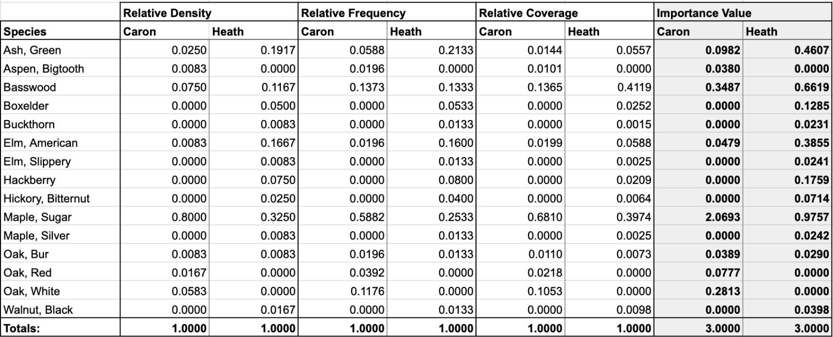

Table 2. Average measurements of abiotic factors at Caron Park and Heath Creek in Rice County, Minnesota. Measurements include above and below ground temperature, light levels, humidity, wond, and soil data. There were few notable differences between the two locations.
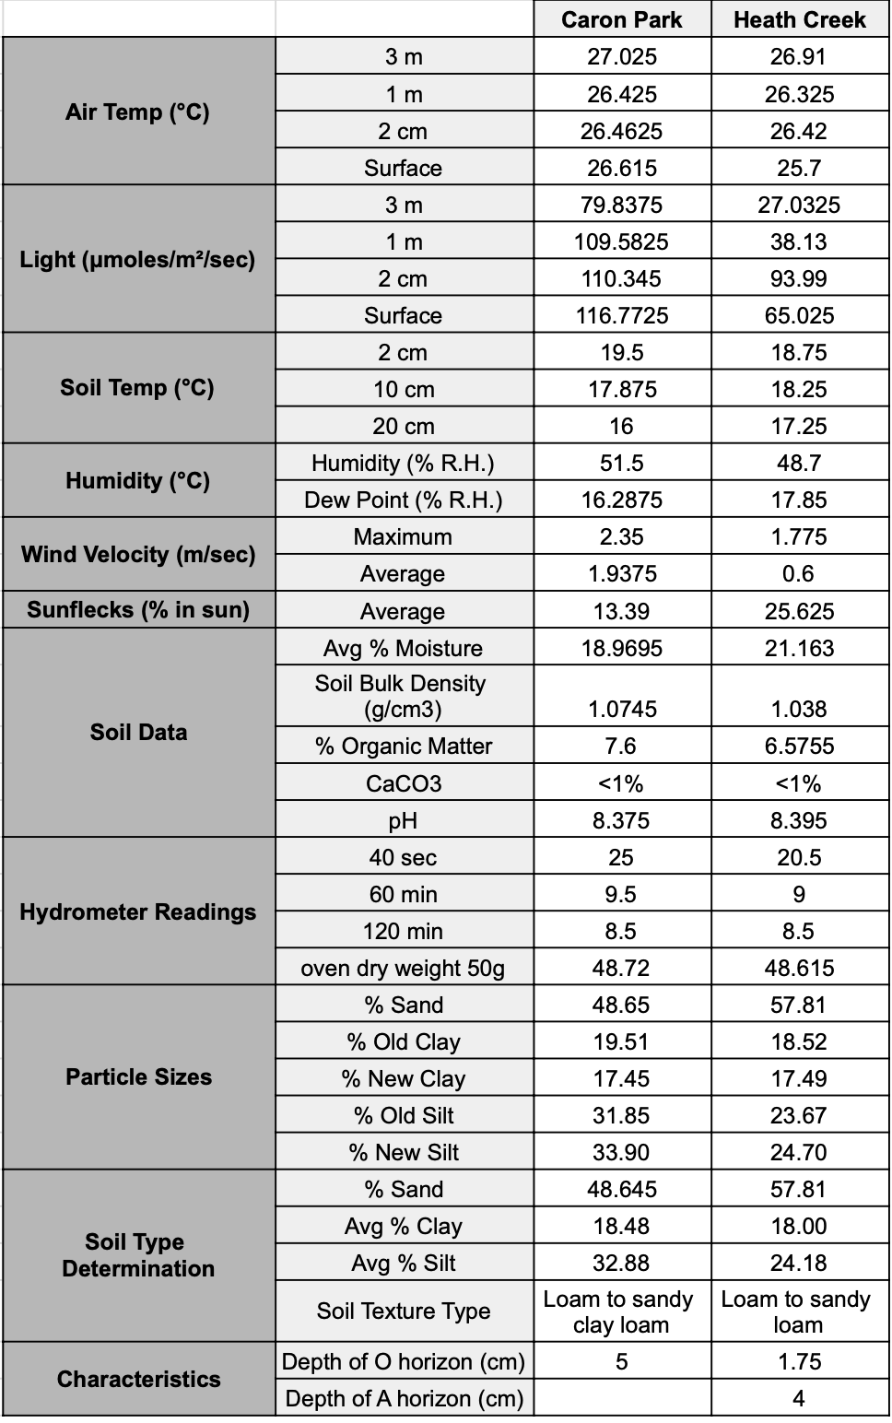
Table 3. Expected number of seedling, sapings, and mature trees of each species in 10,000ha in Caron Park and Heath Creek, two maple-basswood forest fragments in Rice County, Minnesota. At both locations sugar maple are the most common species at all three growth levels, with basswood being the second most common at the sapling and mature tree stages.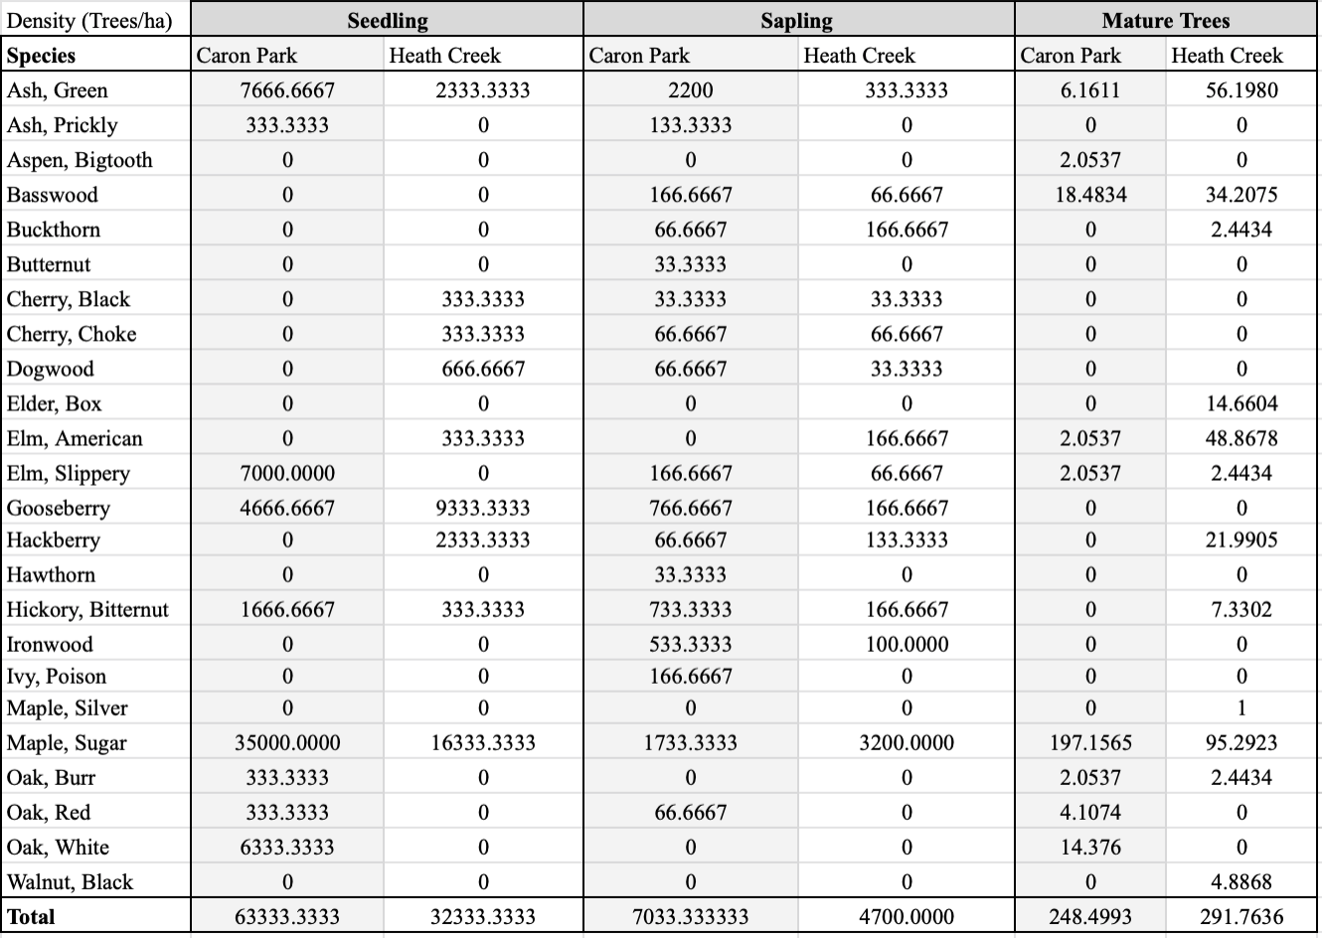

A
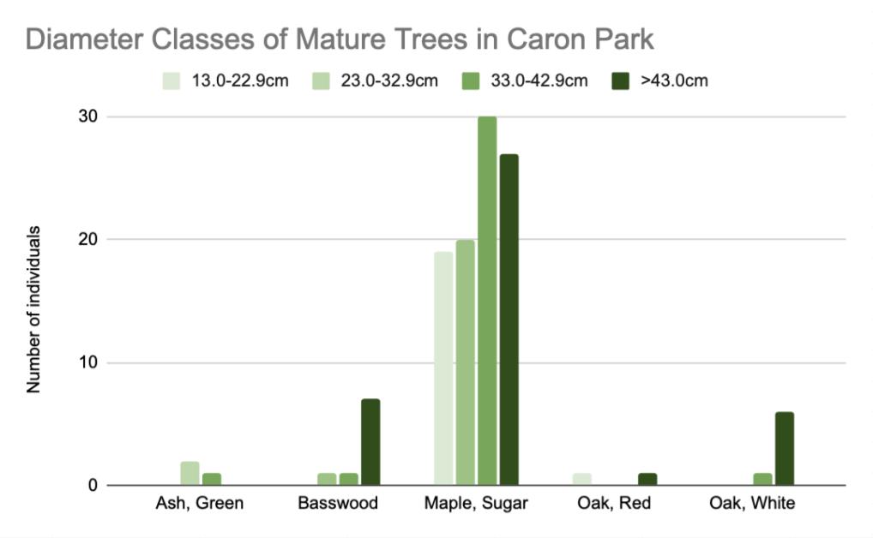
B
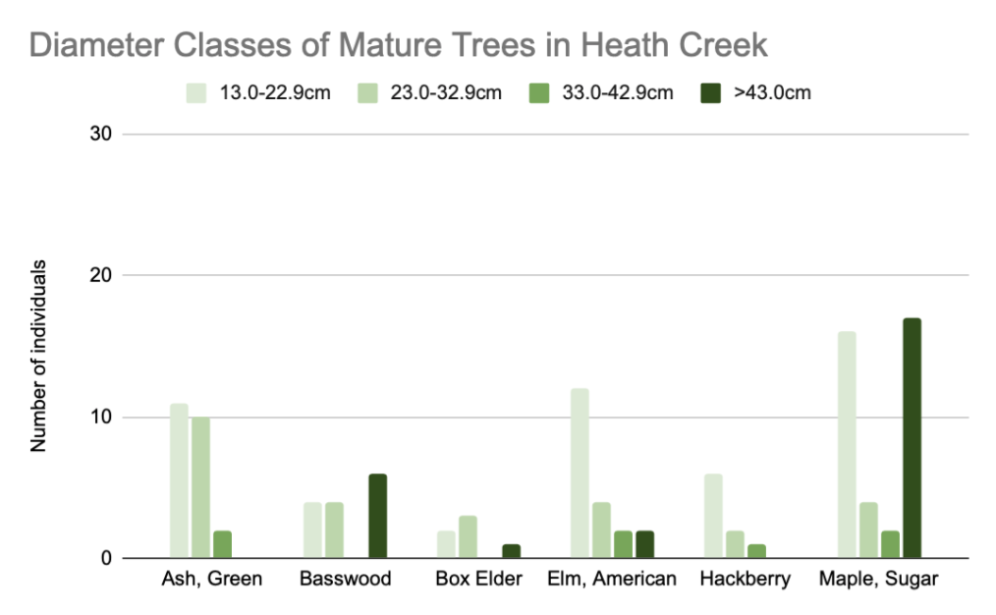

Fig 1. A) Number of individuals of the most frequent species in each DBH diameter class (13.0-22.9cm, 23.0cm-32.9cm, 33.0sm-42.9cm, >43.0cm) at Heath Creek in Rice County, Minnesota. Sugar maple had the majority of individuals at the >43.0 diameter class at the 13.0-22.9 diameter class. Green ash had the most individuals at the 23.0-32.9 diameter class. Green ash, American elm, and sugar maple ties for the highest number of individuals at the 33.0-42.9 diameter class. B) Number of individuals of the most frequent species in each DBH diameter class (13.0-22.9cm, 23.0cm-32.9cm, 33.0sm-42.9cm, >43.0cm) at Caron Park in Rice County, Minnesota. Sugar maple had the overwhelming majority of individuals at all four diameter classes.

